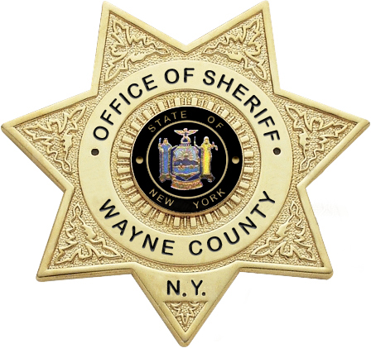

Wayne County Sheriff’s Office
7376 Route 31, Suite 1000
Lyons, New York 14489
Phone 315.946.5799
Fax 315.946.5811

Wayne County STOP DWI
2025 Victim’s Impact Panel Schedule

Attendee ___________________________________ Phone Number ___________________
Please Print

Monday, March 17, 2025 6:00-7:30pm__________________________

Monday, June 9, 2025 6:00-7:30pm__________________________

Monday, September 8, 2025 6:00-7:30pm__________________________

Monday, December 8, 2025 6:00-7:30pm__________________________

Location: Wayne County Court House
Supervisors Chambers
26 Church Street, 2nd Floor
Lyons, New York 14489

All attendees must be pre-registered by the Court.
If not by the Court; ATTENDEE MUST CALL the Wayne County Sheriff’s Office at
315.946-5799 or fax registration information to 315.946-5811

The facility is wheelchair accessible.

Please be on time. No one admitted after attendance is closed.

No guests. No food. No drinks allowed.

No cell phones permitted in the building.

All in Attendance will be screened for alcohol.

All attendees must sign a verification of identity form and submit a thumbprint.

An attendance verification form will be provided to each attendee at the end of the presentation and it is the attendee’s responsibility to return the form to the court.

Robert Milby, Sheriff
Wayne County

